**Certificates**: [**https://citria.org/profile/Certificates**](https://citria.org/profile/Certificates)

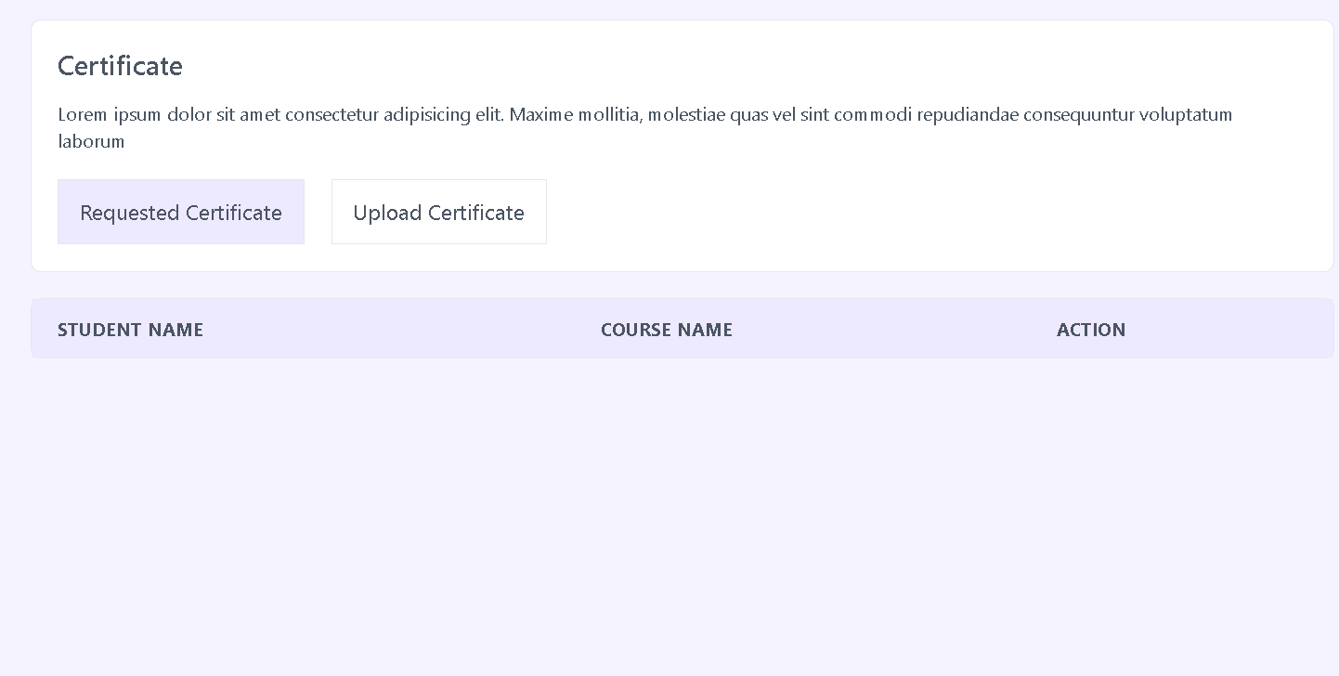

The provided React component is a functional component named Certificates. Here's an overview of its key features:

1. Component Structure

Imports: The component imports the React library and a custom PageTitle component from the '../../Shared/PageTitle' path.

Functional Component: The Certificates component is a functional component, denoted by the arrow function syntax.

2. JSX Structure

PageTitle Component: The PageTitle component is rendered, receiving the prop title with the value 'Certificates'. This suggests that the component is responsible for displaying a page title.

Container Divs: The component contains nested <div> elements with specific styling classes from the Tailwind CSS framework. These classes are used for layout and styling purposes.

Content: Inside the innermost <div>, there is a heading <h1> displaying the text 'Certificates'. Below the heading, there is a paragraph <p> stating, "After a course completion, you will get a Certificate."

3. Styling

Tailwind CSS Classes: The component utilizes Tailwind CSS classes for styling, including margin, padding, borders, and text colors.

4. Purpose

Page Title: The main purpose of this component seems to be displaying information related to certificates, potentially in the context of completing a course.